

American International University-Bangladesh (AIUB)  
**Department of Computer Science  
Faculty of Science & Technology (FST)**

**Project Title:   
Integrated Application Usage Tracking & Parental Control System**

**Supervised by:**

TONNY SHEKHA KAR

A Software Engineering Project Submitted

By

|  |  |  |  |  |
| --- | --- | --- | --- | --- |
| **Semester: Summer_23_24** | | **Section: H** | **Group Number: 09** | |
| SN | Student Name | Student ID | Contribution (CO3+CO4) | Individual Marks |
| 1 | A. F. M. RAFIUL HASSAN | 22-47048-1 | 50% |  |
| 2 | MD. ASHIKUZZAMAN ABIR | 22-47006-1 | 50% |  |
|  |  |  |  |  |
|  |  |  |  |  |
|  |  |  |  |  |

The project will be Evaluated for the following Course Outcomes

|  |  |  |
| --- | --- | --- |
| **CO3:** *Select* appropriate software engineering models, project management roles and their associated skills for the complex software engineering project and evaluate the sustainability of developed software, taking into consideration the societal and environmental aspects | Total Marks | |
|  | |
| Appropriate Process Model Selection and Argumentation with Evidence | [5Marks] |  |
| Evidence of Argumentation regarding process model selection | [5Marks] |  |
| Analysis the impact of societal, health, safety, legal and cultural issues | [5Marks] |  |
| Submission, Defense, Completeness, Spelling, grammar and Organization of the Project report | [5Marks] |  |
| **CO4:** *Develop* project management plan to manage software engineering projects following the principles of engineering management and economic decision process | Total Marks | |
|  | |
| Develop the project plan, its components of the proposed software products | [5Marks] |  |
| Identify all the activities/tasks related to project management and categorize them within the WBS structure. Perform detailed effort estimation correspond with the WBS and schedule the activities with resources | [5Marks] |  |
| Identify all the potential risks in your project and prioritize them to overcome these risk factors. | [5Marks] |  |

Description of Student’s Contribution in the Project work

|  |
| --- |
| Student Name: A. F. M. RAFIUL HASSAN  Student ID: 22-47048-1  Contribution in Percentage (%): 50%  Contribution in the Project:   * Model selection. * Roles and responsibility * Impact on society, environment and cultural * Functional requirements/Non Functional requirements * Project proposal * Use Case Diagram * Class diagram * Activity diagram * Sequence diagram * UI/UX Design * Software Testing * Work Breakdown Structure * Timeline Chart * Risk Management   ___________________  Signature of the Student |
| Student Name: MD. ASHIKUZZAMAN ABIR  Student ID: 22-47006-1  Contribution in Percentage (%): 50%  Contribution in the Project:   * Model selection. * Roles and responsibility * Impact on society, environment and cultural * Functional requirements/Non Functional requirements * Project proposal * Use Case Diagram * Class diagram * Activity diagram * Sequence diagram * UI/UX Design * Software Testing * Work Breakdown Structure * Timeline Chart * Risk Management   ___________________  Signature of the Student |

# PROJECT PROPOSAL

## Background to the Problem

Today's digital landscape presents challenges in maintaining efficient performance and resource allocation due to the widespread use of applications across platforms. Organizations mainly depend on these applications; but, in the absence of appropriate monitoring and control systems, they face into the risks of resource misuse and failure. Considering this standpoint, the goal of our project is to create an effective application monitoring and usage restriction system with parental control system. We deliver real-time insights into user behavior and application performance with powerful monitoring tools. Administrators can also impose limitations to guard resources, maximize efficiency, stop misuse, and enhance user experience. In the end, our solution gives organizations the ability to work in the world of technology more effectively.

The necessity for monitoring applications and limit their usage from the dynamic nature of modern digital environments and the growing dependence on applications for business operations. With the proliferation and complexity of applications, there is an increased risk of performance issues, resource contention, and security vulnerabilities. Without proper monitoring and control measures, organizations face the threat of service disruptions, compromised user experiences, and inefficient resource allocation. In today's connected world, achieving client demands and remaining competitive requires not only ensuring smooth application operation but also securing crucial assets and maintaining service quality standards.

## Solution to the Problem

The project's goal is to create a comprehensive usage limitations and application monitoring system that will tackle the issues raised by the rapidly changing digital environment. This involves utilizing powerful monitoring applications to provide real-time insights into application performance, resource usage, and user behavior.

The proposed solution for addressing the challenges of application monitoring and usage limitation involves developing a comprehensive software platform with strong monitoring tools and usage limitation and restriction features. This solution is unique in that it gives administrators the ability to set thresholds and enforce restrictions to stop abuse or excessive usage while providing real-time data on application performance and resource usage.

The suggested system would transform application monitoring and usage restrictions by leveraging modern technologies such as machine learning algorithms and analytical prediction. It improves system reliability and safety rapidly by using AI-driven anomaly detection to identify and fix significant issues with performance later on.

**Basic Functionalities:**

* **Real-Time Performance Monitoring:** Visual representation of application performance metrics such as response times, error rates, and throughput. Monitor CPU, memory, disk I/O, and network usage in real time.
* **Usage Limitation and Control:** Allow administrators to define usage limits for resources and applications. Manage user roles and permissions to enforce application usage policies.
* **AI driven Anomaly Detection and Alerts:** Use machine learning to identify unusual patterns in application performance and user behavior. Send real-time alerts via email, SMS, or other channels when anomalies or threshold breaches are detected.
* **User Behavior Analysis:** Monitor individual user sessions for detailed insights into behavior and experience. Generate reports on user activity, highlighting areas for optimization.
* **Reporting and Visualization:** Generate detailed reports on application performance, resource usage, and user behavior. Use graphs, charts, and heatmaps to present monitoring data in an understandable format.
* **Security and Compliance:** Ensure compliance with data privacy regulations by anonymizing and securing user data. Maintain detailed logs of all monitoring activities and administrative actions. Track and respond to security incidents, such as unauthorized access or data breaches.

**Targeted Users & Benefits:** The proposed solution targets IT administrators, system operators, and application developers responsible for digital infrastructure management. IT administrators gain real-time insights for proactive troubleshooting, allowing them to quickly identify and resolve issues, thus minimizing downtime. While system operators enforce usage limitations to prevent troubleshooting. Improved insight into user behavior helps application developers create more effective applications.

**Contribution to Scientific Development:** The project makes significant improvements to the field of application monitoring and usage limitation by using innovative methodologies and technologies to provide valuable insights into application performance, resource utilization, and user behavior. The meticulously documented results serve as a foundation for future research, which is spread through published articles and conferences, developing innovation and teamwork within the scientific community.

**Literature Review:** The existing literature has extensively investigated application monitoring and usage limitations, emphasizing their importance in improving performance and resource allocation in digital environments. While previous research has focused on aspects such as performance monitoring and resource utilization optimization, many studies have approached these issues separately, ignoring their interconnected nature.

**Existing Studies**: Existing research on application monitoring and usage restriction includes monitoring performance, allocation of resources, and user behavior analysis. Some concentrate on real-time performance monitoring methods that apply data analysis and anomaly detection, while others look at resource allocation optimization strategies. The study also looks into user behavior analysis in order to make informed resource allocation decisions.

**Existing Software Solution:** Existing software solutions for integrated application usage tracking & parental control system, such as New Relic, Datadog, and Prometheus, provide robust monitoring but may not include extensive usage limitation features. Cloud service providers have some constraints but lack adaptability for complicated environments. Our system combines advanced monitoring tools with customizable usage limitations, implementing technologies such as machine learning to enable proactive monitoring and dynamic modification based on workload and behavior.

# SOFTWARE DEVELOPMENT LIFE CYCLE

## Process Model

**Selected Process Model and Argumentation with Evidence:** The process model "Incremental Development" has been chosen for our project, "Integrated Application Usage Tracking & Parental Control System." This is also known as iterative development.

The requirements of our project are very well known. In this process model, the whole project is divided into several increments and the core product has priority. The primary product takes precedence in this process model, which divides the entire project into multiple increments. It may be possible to deliver the highest priority requirements earlier by using the incremental development process framework. The reason this process model was chosen is that there is less chance of a project failing as a whole, and the system services with the highest importance usually experience the most testing.

Since our project requirements are well known. So, there is no need to update them. This is why we avoid the Agile process model. Examples include the XP process model, DSDM, and others. This is not a big project. As a result, FDD is not chosen because it is typically used for larger projects with many developers. SCRUM is also appropriate for embedded system-related projects, so we avoid using this process model. Other SE models, such as the Waterfall process model and the V model, are not used because the Waterfall is an inflexible and linear process with a high failure rate.

## Project Role Identification and Responsibilities

By using the incremental model in software engineering, a project is usually divided into smaller, easier-to-manage increments, or iterations. Every iteration improves and enhances the software incrementally while sticking to an equivalent development procedure. These are some basic roles and responsibilities within an incremental model process; however, they might change based on the particular project and team structure. In this process model, the following roles are mostly present.

1. **Project Manager:**

* Overall responsibility for planning, organizing, and coordinating the incremental development process.
* Define project objectives, scope, and milestones for each iteration.
* Allocate resources, manage budgets, and track progress.
* Ensure effective communication and collaboration among team members.

1. **Product Owner:**

* Represents the stakeholders and end-users.
* Defines and prioritizes features and requirements for each iteration based on business value and user feedback.
* Collaborates with the development team to refine and clarify requirements as needed.
* Accepts or rejects completed increments based on predefined acceptance criteria.

1. **Development Team:**

* Software Developers: Responsible for designing, coding, and testing the software increments.
* Quality Assurance (QA) Engineers: Ensure the quality and reliability of each increment through testing and validation.
* User Experience (UX) Designers: Design user interfaces and ensure a positive user experience.
* Technical Writers: Create documentation and user manuals for the software increments.
* DevOps Engineers: Manage the deployment, configuration, and maintenance of the software increments.

1. **Stakeholders:**

* Provide feedback on completed increments and participate in reviews and demonstrations.
* Collaborate with the product owner to prioritize features and requirements for future iterations.
* Support the development team by providing domain knowledge and resources as needed.

Overall, the incremental model encourages a collaborative and iterative approach to software development, with roles and responsibilities distributed among team members to ensure the successful delivery of incremental value to stakeholders.

**Impact of the Developed Software on Society and Environment:** Our developed software “Integrated Application Usage Tracking & Parental Control System” can have both positive and negative impacts on society and the environment. Here's an evaluation of its sustainability:

1. **Society:**

* Positive Impact:

1. Increased awareness: Monitoring applications can help users become more aware of their digital habits and encourage them to limit their usage, leading to improved mental health and well-being.
2. Productivity improvement: By monitoring application usage, individuals and organizations can identify time-wasting activities and focus on more productive tasks, potentially leading to higher efficiency and effectiveness.

* Negative Impact:

1. Privacy concerns: Constant monitoring of application usage may raise privacy concerns among users, as it involves tracking their digital activities and potentially collecting sensitive data.
2. Dependency on technology: Over-reliance on monitoring tools to regulate usage may prevent individuals from developing self-discipline and managing their screen time effectively without external intervention.
3. **Environment:**

* Positive Impact:

1. Energy conservation: Limiting application usage can reduce the energy consumption of devices, leading to lower carbon emissions and a smaller environmental footprint.
2. E-waste reduction: Decreasing the frequency of device usage can prolong their lifespan, reducing the need for frequent upgrades and minimizing electronic waste generation.

* Negative Impact:

1. Increased server load: Constant monitoring of applications and their usage data may require additional server resources, leading to higher energy consumption in data centers and contributing to environmental degradation.
2. Electronic device disposal: Limiting application usage may lead to a longer lifespan for electronic devices, but eventually, they will still need to be disposed of, contributing to e-waste accumulation unless proper recycling measures are taken.
3. **Cultural:**

* Positive Impact:

1. Cultivation of digital wellness: Emphasizing the importance of balanced technology usage can foster a cultural shift towards prioritizing mental health and well-being over constant connectivity and digital consumption.
2. Promotion of cultural values: Application monitoring and usage limits can align with cultural values emphasizing moderation, self-discipline, and mindful consumption, contributing to a healthier societal ethos.

* Negative Impact:

1. Resistance to change: Cultural norms and habits around technology usage may resist efforts to implement monitoring and restriction measures, leading to pushback and potential cultural conflicts.
2. Technological dependency: Over-reliance on monitoring tools to regulate behavior may exacerbate cultural tendencies towards technological dependency, undermining efforts to cultivate self-control and autonomy.

In summary, the sustainability of integrated application usage tracking & parental control system requires careful consideration of its societal, environmental, and cultural impacts. Balancing the benefits of promoting digital wellness and environmental conservation with potential drawbacks such as privacy concerns and cultural resistance is essential for fostering a sustainable relationship with technology.

# FUNCTIONAL REQUIREMENTS

**1. Software Registration**

**1.1** The user should provide a valid email address for registration.

* **Priority Level**: High
* **Precondition**: None

**1.2** The user should provide a valid phone number for registration.

* **Priority Level**: High
* **Precondition**: None

**1.3** The user should provide a valid and unique username at registration.

* **Priority Level**: High
* **Precondition**: None

**1.4** The user should provide their date of birth during registration.

* **Priority Level**: High
* **Precondition**: None

**1.5** The user should provide a valid password of at least 6 characters, including a mixture of uppercase letters, lowercase letters, and numbers during registration.

* **Priority Level**: High
* **Precondition**: None

**1.6** The user should confirm the provided password.

* **Priority Level**: High
* **Precondition**: The user entered the password same as the provided password

**2. Software Login**

**2.1** The software shall allow users to log in with their given username and password.

* **Priority Level**: High
* **Precondition**: The user has a valid username and password.

**2.2** The email address and password shall be verified with database records.

* **Priority Level**: High
* **Precondition**: The user has entered login credentials.

**2.3** If the login is successful, the home page of the user account shall be displayed.

* **Priority Level**: High
* **Precondition**: The user has entered valid login credentials.

**2.4** If the email address and/or password are incorrect, the system shall prompt the user to enter the correct email address and password and retry login.

* **Priority Level**: High
* **Precondition**: The user has entered incorrect login credentials.

**2.5** If the number of login attempts exceeds its limit (3 times), the system shall block the user account login for 24 hours.

* **Priority Level**: Medium
* **Precondition**: The user has attempted to log in with incorrect credentials more than 3 times.

**3. Authentication**

**3.1** Users shall enter their email address or phone number to verify their created account.

* **Priority Level**: High
* **Precondition**: The user has completed the registration process.

**3.2** An OTP shall be sent to the user's email address or phone number.

* **Priority Level**: High
* **Precondition**: The user has requested for account verification.

**3.3** If the OTP is sent successfully within 60 seconds, the user shall enter the OTP to verify.

* **Priority Level**: High
* **Precondition**: The OTP has been sent successfully.

**3.4** If the OTP is not sent successfully within 60 seconds, a new OTP shall be resent.

* **Priority Level**: High
* **Precondition**: The OTP sending process has failed.

**4. Usage Monitoring**

**4.1** The user and their parents shall be able to view device usage.

* **Priority Level**: Medium
* **Precondition**: The user has logged in.

**4.2** The system shall provide statistics of total screen time over the last 30 days.

* **Priority Level**: Medium
* **Precondition**: The user has logged in.

**4.3** The system shall provide details about which apps are used over the period and how much time they are used.

* **Priority Level**: Medium
* **Precondition**: The user has logged in.

**4.4** The user and their parents shall be informed about the visited websites.

* **Priority Level**: Medium
* **Precondition**: The user has logged in.

**4.5** The system shall show the list of locked and unlocked apps.

* **Priority Level**: Medium
* **Precondition**: The user has logged in.

**4.6** All the history mentioned above shall be displayed for the last 30 days, after which the history shall be deleted automatically.

* **Priority Level**: Medium
* **Precondition**: The user has logged in.

**5. App Blocking and Filtering**

**5.1** The system shall allow parents to block or restrict access to specific apps or websites deemed inappropriate or excessive.

* **Priority Level**: High
* **Precondition**: The parent has logged in.

**5.2** The system shall implement content filtering based on categories such as violence, adult content, gambling, etc.

* **Priority Level**: High
* **Precondition**: The parent has logged in.

**6. Screen Time Management**

**6.1** The user and parents shall have access to set time limits for device usage per day or app.

* **Priority Level**: High
* **Precondition**: The user or parent has logged in.

**6.2** The system shall allow scheduling of device usage time, such as allowing access only during certain hours like homework hours and bedtime.

* **Priority Level**: High
* **Precondition**: The user or parent has logged in.

**6.3** The system shall provide warnings or notifications as usage limits approach or when time is exceeded.

* **Priority Level**: High
* **Precondition**: The user or parent has logged in.

**6.4** After issuing a warning, the system shall automatically close the apps or systems when usage time is exceeded.

* **Priority Level**: High
* **Precondition**: The usage limit has been exceeded.

**7. Location Tracking and Geofencing**

**7.1** The parent shall have access to GPS tracking to locate the device and provide information about the child's location.

* **Priority Level**: High
* **Precondition**: The parent has logged in and has enabled location tracking.

**7.2** The system shall allow setting up geofences to receive alerts when the child enters or leaves specific locations such as home, school, or forbidden places.

* **Priority Level**: High
* **Precondition**: The parent has logged in and has set up geofences.

**8. Customizable Profiles and Settings**

**8.1** The system shall support multiple user profiles for different family members with individualized settings.

* **Priority Level**: Medium
* **Precondition**: The parent has logged in.

**8.2** The guardian shall be able to log in to the system from their device and control children's activities.

* **Priority Level**: Medium
* **Precondition**: The parent has logged in.

**8.3** The system shall allow customization of restrictions and permissions based on age or user preferences.

* **Priority Level**: Medium
* **Precondition**: The parent has logged in.

**9. Emergency Features**

**9.1** The system shall develop features to quickly alert parents or guardians in case of emergencies, such as panic buttons, emergency contacts, or automated notifications.

* **Priority Level**: High
* **Precondition**: The emergency feature is enabled.

**9.2** The system shall send an emergency notification if the child visits forbidden apps or websites.

* **Priority Level**: High
* **Precondition**: The emergency feature is enabled.

**9.3** The guardians shall be notified when the child starts searching any forbidden website.

* **Priority Level**: High
* **Precondition**: The emergency feature is enabled.

**10. Remote Management**

**10.1** The system shall implement APIs or protocols for remote management of devices and settings.

* **Priority Level**: High
* **Precondition**: The parent has logged in.

**10.2** The system shall allow parents to control and monitor their children's devices from anywhere with an internet connection.

* **Priority Level**: High
* **Precondition**: The parent has logged in and has an internet connection.

**11. Activity Insights and Recommendations**

**11.1** The system shall utilize machine learning and data analytics techniques to provide actionable insights and personalized recommendations for improving digital well-being and usage habits.

* **Priority Level**: Medium
* **Precondition**: The user has logged in.

**12. Data Privacy and Security**

**12.1** The system shall implement strong encryption methods to secure sensitive user data.

* **Priority Level**: High
* **Precondition**: The user has logged in.

**12.2** The system shall secure login information, personal information, and communication between devices.

* **Priority Level**: High
* **Precondition**: The user has logged in.

**13. Access Request for New App**

**13.1** For installing a new app, users (children) shall send an access request to the admin (parent).

* **Priority Level**: High
* **Precondition**: The child has logged in and attempting to install a new app.

**13.2** Only the admin (parent) shall have access to accept or reject the access request.

* **Priority Level**: High
* **Precondition**: The parent has logged in.

**14. Educational Resources**

**14.1** The system shall offer educational materials and resources for parents and children to promote digital literacy and responsible online behavior.

* **Priority Level**: Medium
* **Precondition**: The user has logged in.

**15. Live Screen Monitoring**

**15.1** Parents shall be able to monitor their children's phone screens in real-time.

* **Priority Level**: High
* **Precondition**: The parent has logged in and has enabled live screen monitoring.

**15.2** Children’s phones shall not be notified during the live screen monitoring.

* **Priority Level**: High
* **Precondition**: The parent has enabled live screen monitoring.

**16. Software Logout**

**16.1** Only the admin (parent) shall be able to sign out from this software at any time after a successful login.

* **Priority Level**: High
* **Precondition**: The parent has logged in.

# NON FUNCTIONAL REQUIREMENTS

### Usability

* **Ease of Registration:** A new user should be able to complete the registration process within an average of three minutes and a maximum of five minutes.
  + **Priority Level:** High
* **Login Efficiency:** A returning user should be able to log in within an average of two minutes, including the verification process if applicable.
  + **Priority Level:** High
* **User Interface:** The user interface shall be intuitive and easy to navigate, requiring no more than five clicks to access any major function.
  + **Priority Level:** Medium

### Performance

* **Response Time:** The system shall respond to all user actions, such as registration, login, and configuration changes, within two seconds under normal conditions.
* **Priority Level:** High
* **OTP Delivery:** The OTP for authentication shall be delivered within 60 seconds 95% of the time.
* **Priority Level:** High
* **Real-time Monitoring:** The live screen monitoring feature shall update every five seconds with minimal lag.
* **Priority Level:** Medium

### Availability

* **System Uptime:** The system shall have an uptime of 99.9%, allowing for no more than 8.76 hours of downtime annually.
* **Priority Level:** High
* **Disaster Recovery:** The system shall have a recovery time objective (RTO) of one hour and a recovery point objective (RPO) of 15 minutes.
* **Priority Level:** High

### Security

* **Data Encryption:** All sensitive data, including personal information, passwords, and usage logs, shall be encrypted at rest and in transit using AES-256 encryption.
* **Priority Level:** High
* **Access Control:** The system shall implement role-based access control (RBAC) to ensure only authorized users can perform administrative functions.
* **Priority Level:** High
* **Login Security:** The system shall support multi-factor authentication (MFA) for all accounts to enhance security.
* **Priority Level:** High

### Capacity

* **User Capacity:** The system shall support up to 100,000 registered users, with the capability to scale up to 1,000,000 users.
* **Priority Level:** Medium
* **Data Storage:** The system shall be capable of storing detailed usage data for at least one year for all users, with an automatic purge of data older than one year.
* **Priority Level:** Medium

### Maintainability

* **Modular Architecture:** The system shall be designed using a modular architecture to facilitate easy updates and maintenance.
* **Priority Level:** Medium
* **Code Documentation:** All code shall be thoroughly documented to ensure that future developers can understand and modify it with ease.
* **Priority Level:** Medium

### Documentation

* **User Documentation:** The system shall include comprehensive user manuals and FAQs to help users understand and use all features effectively.
* **Priority Level:** High
* **Technical Documentation:** Detailed technical documentation shall be provided for developers and administrators, including API documentation and system architecture diagrams.
* **Priority Level:** High

### Reliability

* **Error Handling:** The system shall handle errors gracefully, providing clear error messages and guidance for users to resolve issues.
* **Priority Level:** High
* **Retry Mechanism:** The system shall include retry mechanisms for transient failures, such as OTP delivery or network interruptions.
* **Priority Level:** Medium

### Compliance

* **Data Privacy:** The system shall comply with relevant data privacy regulations, such as GDPR and CCPA, ensuring user data is handled appropriately.
* **Priority Level:** High
* **Parental Consent:** The system shall include mechanisms for obtaining and verifying parental consent for child accounts, in compliance with COPPA.
* **Priority Level:** High

### Scalability

* **Load Handling:** The system shall be able to handle a load of up to 10,000 concurrent users without performance degradation.
* **Priority Level:** Medium
* **Elastic Scaling:** The system shall support elastic scaling to accommodate sudden spikes in usage, such as during new feature rollouts or marketing campaigns.
* **Priority Level:** Medium

### Support and Training

* **Customer Support:** The system shall provide 24/7 customer support to assist users with any issues or questions.
* **Priority Level:** Medium
* **Training Resources:** The system shall include training resources, such as video tutorials and webinars, to help users make the most of its features.
* **Priority Level:** Medium

**PROJECT DEVELOPMENT CONSTRAINTS**

1. **Budget Constraints:**
   * The project budget is limited to $500,000, which includes development, testing, deployment, and initial marketing efforts.
   * Any third-party services or APIs used must fit within this budget without compromising essential functionality.
2. **Time Constraints:**
   * The project must be completed within a 12-month timeframe, with the following milestones:

* Requirements Gathering and Planning: 2 months
* Design and Prototyping: 2 months
* Development: 5 months
* Testing and Quality Assurance: 2 months
* Deployment and Launch: 1 month

1. **Resource Constraints:**
   * The development team is limited to 10 members, including developers, testers, UX/UI designers, and project managers.
   * Access to external consultants and specialists is restricted and must be pre-approved based on budget allowances.
2. **Technology Constraints:**
   * The system must be developed using predefined technology stacks, including:
     + Frontend: React.js
     + Backend: Node.js with Express.js
     + Database: MongoDB
     + Mobile Platforms: Android and iOS using React Native
     + Cloud Services: AWS or Azure for hosting and storage
   * Compatibility with legacy systems or platforms outside these stacks is not guaranteed and may require additional resources.
3. **Regulatory Constraints:**
   * The system must comply with GDPR, CCPA, COPPA, and other relevant data protection and privacy regulations.
   * Any data storage and processing must meet local jurisdictional requirements, especially for storing sensitive data related to children.
4. **Quality Constraints:**
   * The system must pass all specified non-functional requirements related to performance, security, and usability before release.
   * All major features must achieve a minimum of 95% test coverage, and critical bugs must be resolved prior to deployment.
5. **Dependency Constraints:**
   * The project is dependent on timely delivery and integration of third-party services such as SMS/Email OTP providers, payment gateways, and map services for geofencing.
   * Delays in these services can impact the overall project timeline and must be managed accordingly.
6. **User and Stakeholder Constraints:**
   * Regular feedback must be incorporated from key stakeholders, including parents, children, educators, and security experts.
   * The system must support multilingual interfaces, at least for English, Spanish, and French, to cater to a broader user base.
7. **Operational Constraints:**
   * Post-launch support and maintenance must be planned within the budget, ensuring that the system operates smoothly and user issues are resolved promptly.
   * Regular updates and feature enhancements must be scheduled to keep the system competitive and secure.
8. **Ethical Constraints:**
   * The system must ensure the ethical use of monitoring and control features, respecting the privacy and autonomy of users, especially children.
   * Clear communication and consent processes must be in place to inform users about data collection and usage policies.

# System Design Specification

**Case Study:**

The Integrated Application Usage Tracking & Parental Control System is a tool that allows parents to manage and monitor their children's device usage effectively. It provides features like tracking screen time, setting time limits, restricting access to certain apps, and notifying parents when children attempt to access restricted content. The system ensures that parents can guide their children’s digital habits while maintaining a balance between usage and restrictions. Key use cases like logging in, monitoring, and setting restrictions are clearly represented, showing the relationships necessary to implement the system's features.

In this system, children log into the device, and the system tracks their usage in real-time. If the child exceeds the set time limit, access to specific apps or the entire device is restricted. The system continuously monitors and records details about app usage and overall screen time. Parents can view this data through a dashboard, where they also set time limits and restrictions. If the child attempts to access restricted apps or needs additional time, the parent is alerted and can choose to approve or deny the request.

The system’s core structure involves components like Monitoring System, which handles app tracking and restrictions, and User, which manages authentication and role-based access for parents and children. The parent interacts with the system to customize restrictions for their child's device, which is then implemented by the system. The sequence of interactions between parent, child, and system ensures real-time monitoring and control, allowing parents to maintain oversight while giving children managed freedom to use their devices.

By offering flexibility and customization, the system ensures that parental controls are easy to set up and adjust, making it a practical solution for managing children’s device usage and fostering healthy digital habits.

**Use Case Diagram:**

**Class Diagram:**

**Activity Diagram:**

**Sequence Diagram:**

**ER Diagram:**

# UI/UX Design:

1. **Splash and User-Guide Screen:**

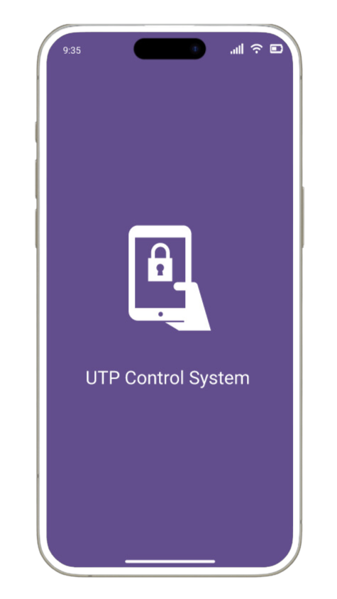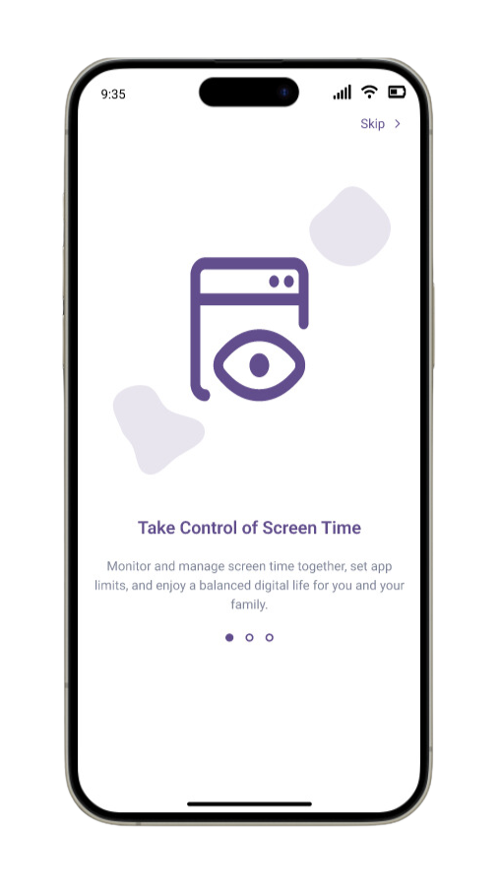

1. **User-Guide Screen (Cont.):**

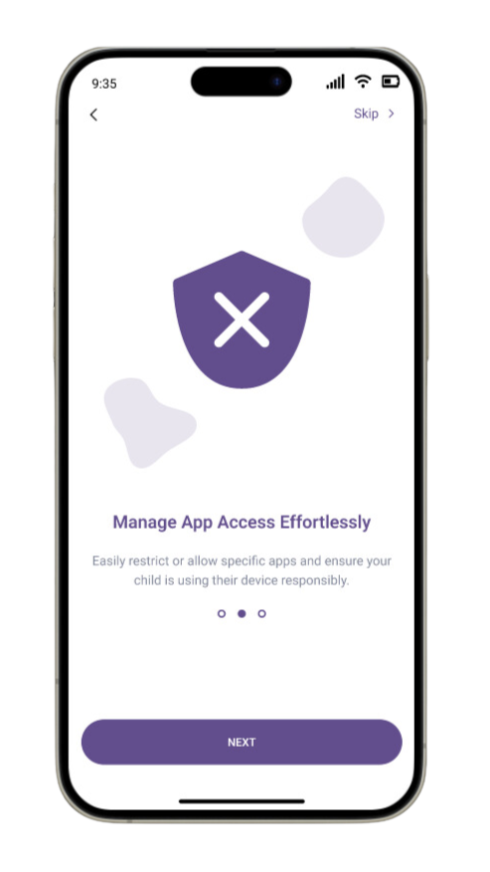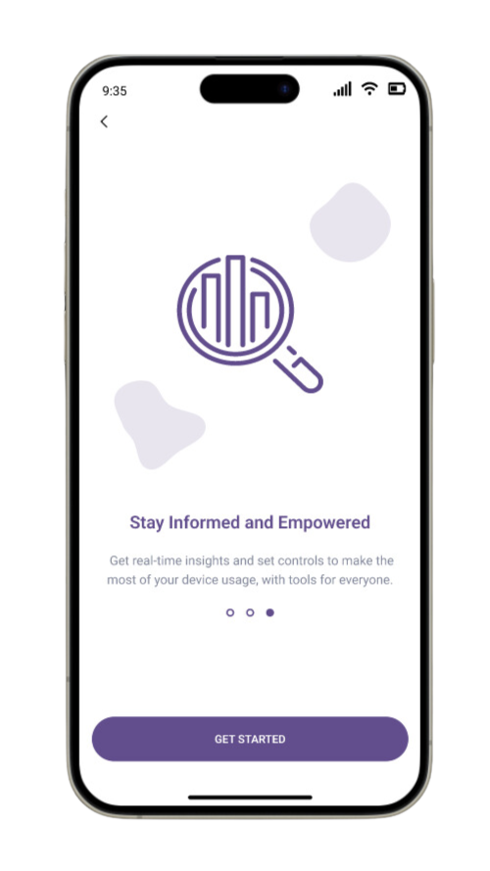

1. **Sign-up and Sign-in Screen:**

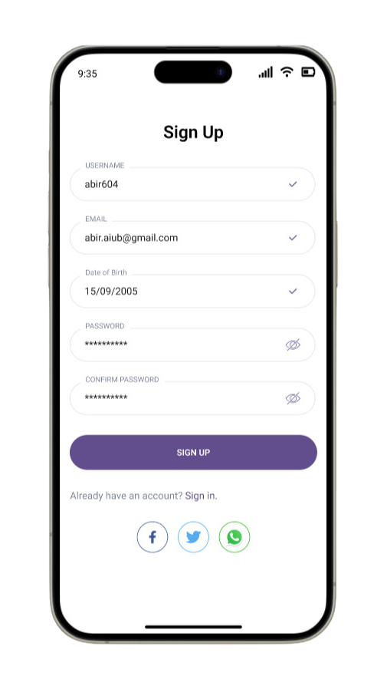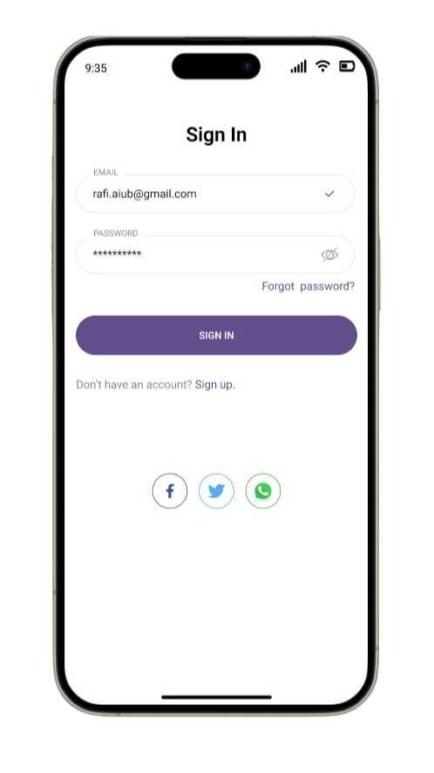

1. **Forget Password and Authentication Screen:**

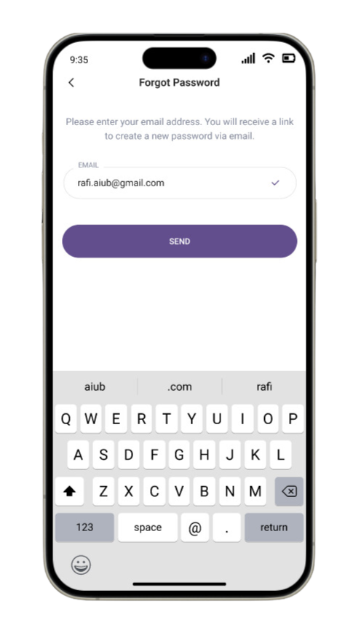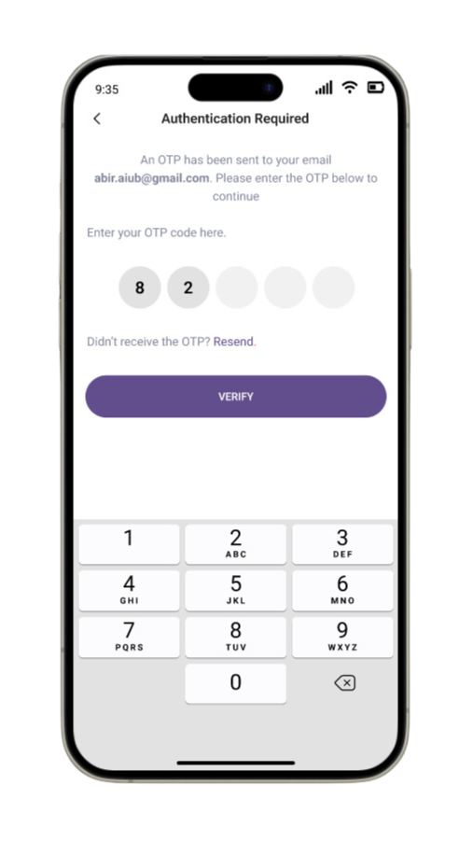

1. **Homepage and Profile Menu Screen:**

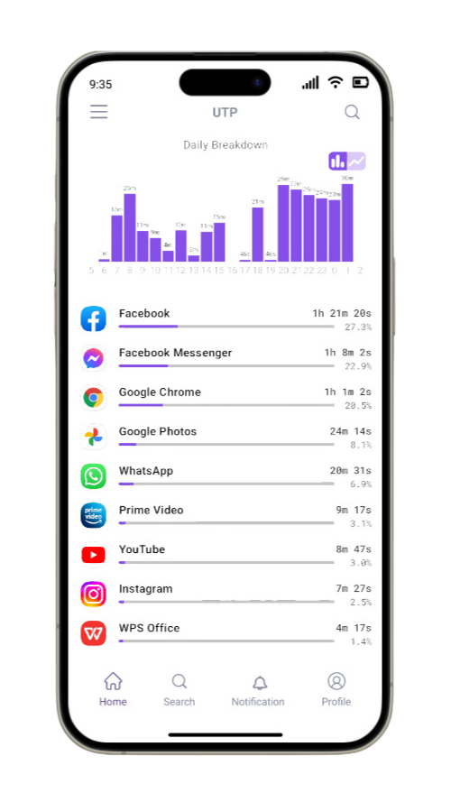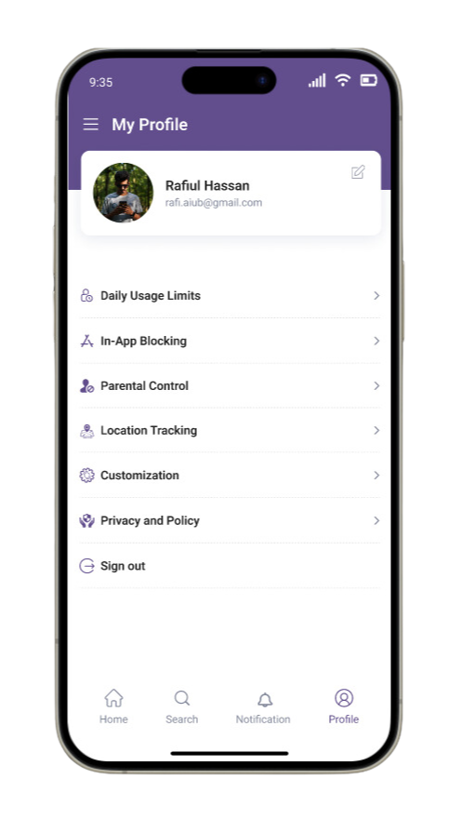

1. **Profile Edit and My Profile Screen:**

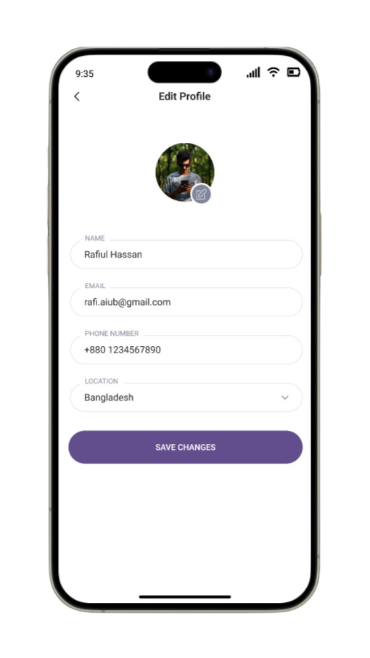

1. **Parental Control System Screen:**

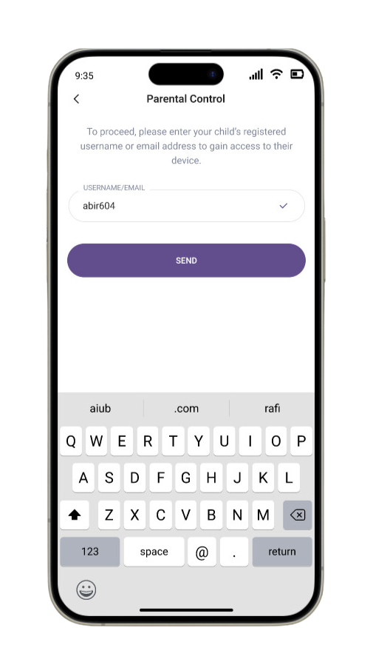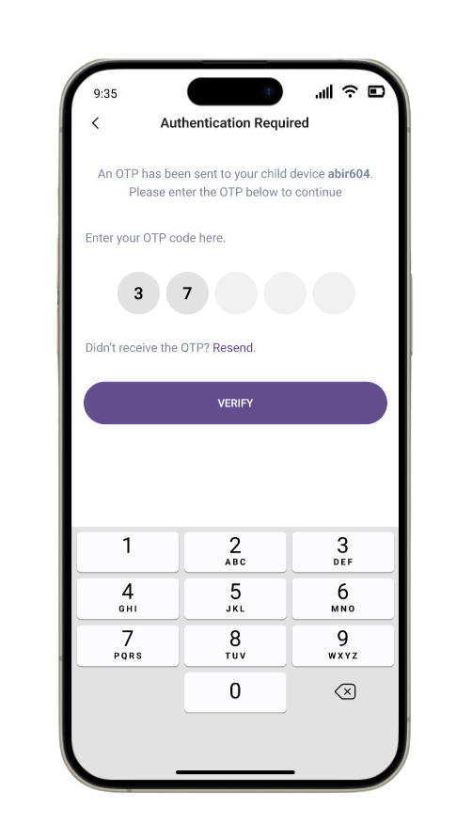

1. **Parental Accessed Screen:**

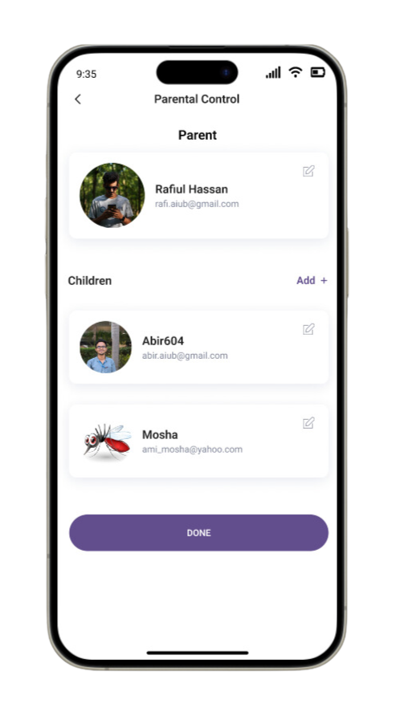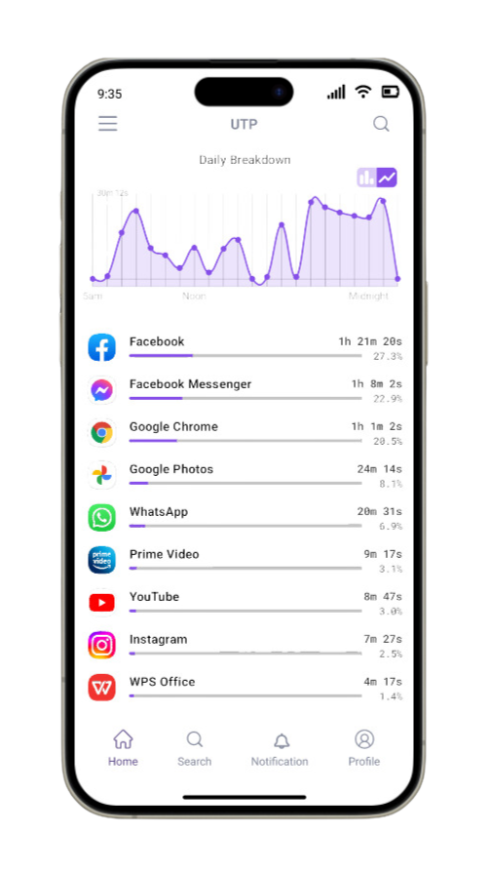

1. **Usage Limits Screen:**

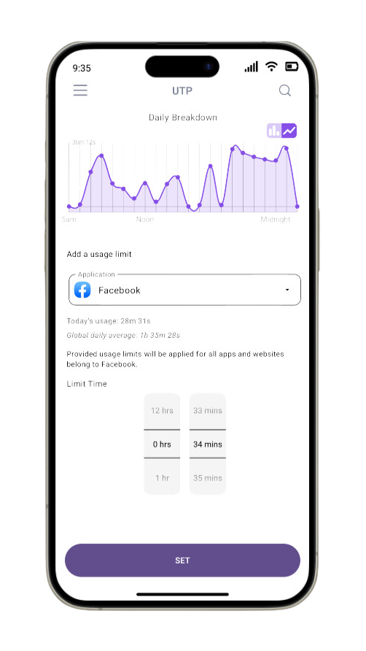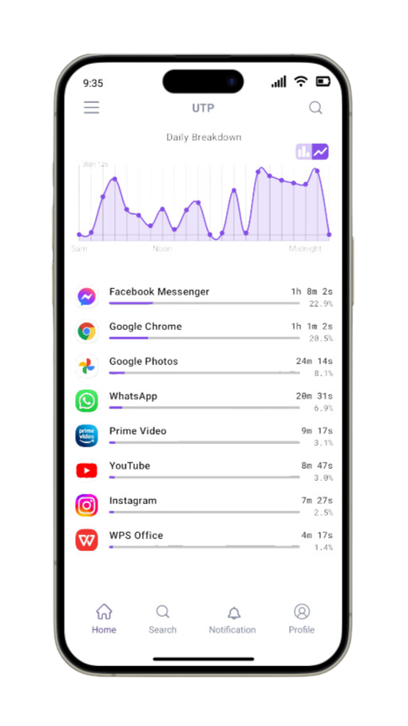

1. **In-App Blocking and Location Tracking Screen :**

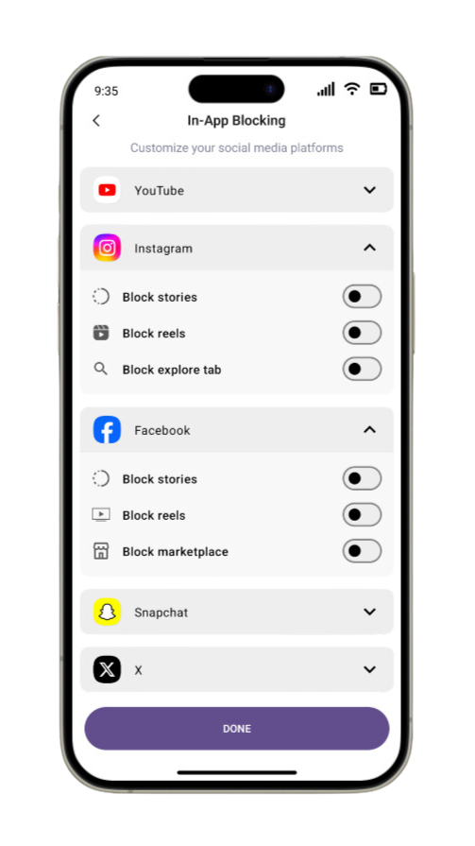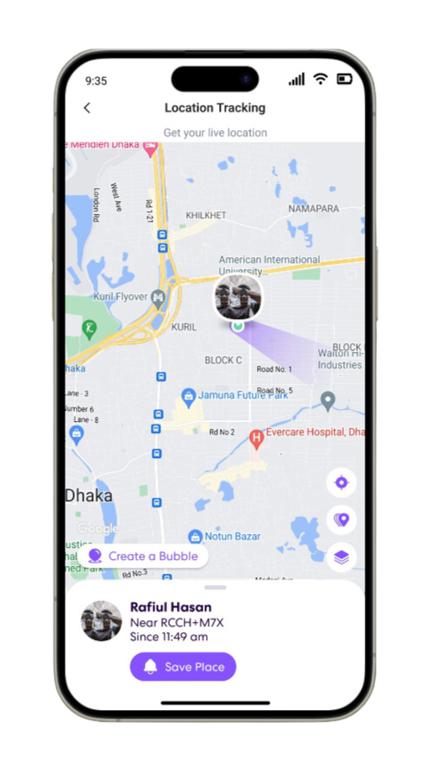

1. **Customization and Privacy-Policy Screen:**

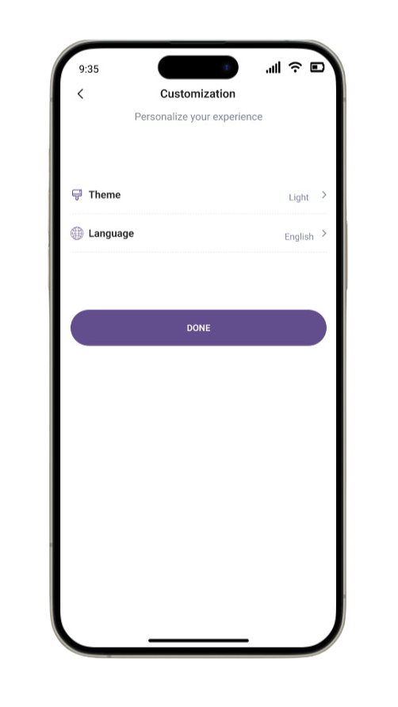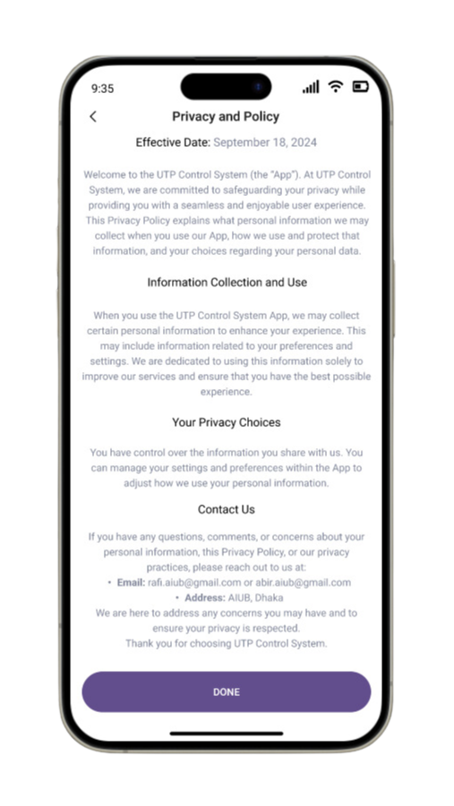

# Project Test Planning:

|  |  |  |  |  |
| --- | --- | --- | --- | --- |
| Project Name: Integrated Application Usage Tracking & Parental Control System | | | Test designed by: MD. ASHIKUZZAMAN ABIR | |
| Test Case ID: UTP-1 | | | Test designed date: 18/09/2024 | |
| Test Priority: High | | | Test Executed by: A. F. M. RAFIUL HASSAN | |
| Module Name: The user sign- up session | | | Test Execution date: 18/09/2024 | |
| Test Title: Verify sign-up with a valid email address, phone number, and unique username, date of birth, and a valid password. | | | | |
| Description: Test the application sign-up page | | | | |
| Pre Condition (if any): The user must have a valid email address, and unique username, date of birth, and password | | | | |
| Test Steps | Test Data | Expected Result | Actual Result | Status(pass/fail) |
| 1. Go to the application 2. Enter email address 3. Enter a phone number 4. Enter username 5. Enter the date of birth 6. Enter password 7. Click the sign-up button | Email: [abir.aiub@gmail.com](mailto:abir.aiub@gmail.com)  Username: Abir604  Date of Birth: 15/09/2005 Password: amiabirnah | The user should sign up for the application |  |  |
| Post Condition: The user is validated with the database and successfully signed up for the application. The account session details are saved in the database. | | | | |

|  |  |  |  |  |
| --- | --- | --- | --- | --- |
| Project Name: Integrated Application Usage Tracking & Parental Control System | | | Test designed by: A. F. M. RAFIUL HASSAN | |
| Test Case ID: UTP-2 | | | Test designed date: 18/09/2024 | |
| Test Priority: High | | | Test Executed by: A. F. M. RAFIUL HASSAN | |
| Module Name: Sign In Session | | | Test Execution date: 18/09/2024 | |
| Test Title: Verify sign-in session with valid email address, and password | | | | |
| Description: Test the application page | | | | |
| Pre Condition (if any): User must have a valid email address and password | | | | |
| Test Steps | Test Data | Expected Result | Actual Result | Status(pass/fail) |
| 1. Go to the sign-in page 2. Enter email address or username 3. Enter password 4. Click the sign in button | Email: [rafi.aiub@gmail.com](mailto:rafi.aiub@gmail.com)  Password: rafibhai | The user should sign-in into the application |  |  |
| Post Condition: The user is validated with the database and successfully signed in to the application. The account session details are saved in the database. | | | | |

|  |  |  |  |  |
| --- | --- | --- | --- | --- |
| Project Name: Integrated Application Usage Tracking & Parental Control System | | | Test designed by: A. F. M. RAFIUL HASSAN | |
| Test Case ID: UTP-3 | | | Test designed date: 18/09/2024 | |
| Test Priority: High | | | Test Executed by: MD. ASHIKUZZAMAN ABIR | |
| Module Name: OTP Verification | | | Test Execution date: 19/09/2024 | |
| Test Title: Verify OTP verification process during login. | | | | |
| Description: Test OTP authentication during login. | | | | |
| Precondition: The user must receive an OTP after entering valid credentials. | | | | |
| Test Steps | Test Data | Expected Result | Actual Result | Status(pass/fail) |
| 1. Complete login credentials entry. 2. Wait for OTP. 3. Enter the OTP in the provided field. 4. Submit OTP. | OTP: 8374 | The user is successfully authenticated and redirected to the dashboard. |  |  |
| Post Condition: user access is granted | | | | |

|  |  |  |  |  |
| --- | --- | --- | --- | --- |
| Project Name: Integrated Application Usage Tracking & Parental Control System | | | Test designed by: MD. ASHIKUZZAMAN ABIR | |
| Test Case ID: UTP-4 | | | Test designed date: 18/09/2024 | |
| Test Priority: Medium | | | Test Executed by: MD. ASHIKUZZAMAN ABIR | |
| Module Name: Customize Profile | | | Test Execution date: 19/09/2024 | |
| Test Title: Verify profile customization functionality | | | | |
| Description: Test if users can update their profile information and preferences | | | | |
| Precondition: The user must be logged into the system. | | | | |
| Test Steps | Test Data | Expected Result | Actual Result | Status(pass/fail) |
| 1. Go to the profile section. 2. Select the "Edit Profile" option. 3. Update personal information (e.g., username, email). 4. Save changes. | New Username: amimosha  New Email: mosha.aiub@gmail.com | The user's profile is successfully updated. |  |  |
| Post Condition: The updated profile is saved in the database. | | | | |

|  |  |  |  |  |
| --- | --- | --- | --- | --- |
| Project Name: Integrated Application Usage Tracking & Parental Control System | | | Test designed by: A. F. M. RAFIUL HASSAN | |
| Test Case ID: UTP-5 | | | Test designed date: 18/09/2024 | |
| Test Priority: High | | | Test Executed by: A. F. M. RAFIUL HASSAN | |
| Module Name: Usage Monitoring | | | Test Execution date: 19/09/2024 | |
| Test Title: Verify daily app usage monitoring | | | | |
| Description: Test if the system monitors and logs application usage | | | | |
| Precondition: The user (child) must be logged into their phone | | | | |
| Test Steps | Test Data | Expected Result | Actual Result | Status(pass/fail) |
| 1. Go to the usage monitoring section. 2. Select the "Daily Usage Limits" option. 3. Check the app usage logs. | No specific data required. | The system displays a log of app usage. |  |  |
| Post Condition: The usage history is saved in the system for future reference. | | | | |

|  |  |  |  |  |
| --- | --- | --- | --- | --- |
| Project Name: Integrated Application Usage Tracking & Parental Control System | | | Test designed by: A. F. M. RAFIUL HASSAN | |
| Test Case ID: UTP-6 | | | Test designed date: 18/09/2024 | |
| Test Priority: High | | | Test Executed by: MD. ASHIKUZZAMAN ABIR | |
| Module Name: App Blocking | | | Test Execution date: 19/09/2024 | |
| Test Title: Verify the app blocking feature | | | | |
| Description: Test if parents can block specific apps on the child’s device | | | | |
| Precondition: The user (parent) must have control over the child’s device | | | | |
| Test Steps | Test Data | Expected Result | Actual Result | Status(pass/fail) |
| 1. Go to the in-app blocking section. 2. Select the apps to block. 3. Apply the block. | App to Block: YouTube | The selected app is successfully blocked on the child’s device. |  |  |
| Post Condition: The blocked app list is updated in the system. | | | | |

|  |  |  |  |  |
| --- | --- | --- | --- | --- |
| Project Name: Integrated Application Usage Tracking & Parental Control System | | | Test designed by: A. F. M. RAFIUL HASSAN | |
| Test Case ID: UTP-7 | | | Test designed date: 18/09/2024 | |
| Test Priority: High | | | Test Executed by: A. F. M. RAFIUL HASSAN | |
| Module Name: Daily Usage Limits - Management | | | Test Execution date: 19/09/2024 | |
| Test Title: Verify daily usage with time scheduling | | | | |
| Description: Test if parents can set screen time limits on the child’s device | | | | |
| Precondition: The user (parent) must have access to screen time controls | | | | |
| Test Steps | Test Data | Expected Result | Actual Result | Status(pass/fail) |
| 1. Go to the daily usage limits section. 2. Click on the app that you want to limits. 3. Set time limits for specific apps or the device. 4. Save and set the schedule. | App: Instagram  Limit: 2 hours/day | The daily usage is successfully managed, and the child’s access is restricted after reaching the limit. |  |  |
| Post Condition: The daily usage screen time limits are stored in the database. | | | | |

|  |  |  |  |  |
| --- | --- | --- | --- | --- |
| Project Name: Integrated Application Usage Tracking & Parental Control System | | | Test designed by: MD. ASHIKUZZAMAN ABIR | |
| Test Case ID: UTP-8 | | | Test designed date: 18/09/2024 | |
| Test Priority: Medium | | | Test Executed by: A. F. M. RAFIUL HASSAN | |
| Module Name: Application Access Request | | | Test Execution date: 20/09/2024 | |
| Test Title: Verify access request approval from child’s device | | | | |
| Description: Test if the child can send an access request to parents for new application | | | | |
| Precondition: The child must have restricted access | | | | |
| Test Steps | Test Data | Expected Result | Actual Result | Status(pass/fail) |
| 1. Child attempts to use a restricted app. 2. Child sends an access request. 3. Parent receives the request. 4. Parent approves or denies the request. | App: Instagram | The access request is processed, and the parent can approve or deny it. |  |  |
| Post Condition: The access request status is updated in the system. | | | | |

|  |  |  |  |  |
| --- | --- | --- | --- | --- |
| Project Name: Integrated Application Usage Tracking & Parental Control System | | | Test designed by: MD. ASHIKUZZAMAN ABIR | |
| Test Case ID: UTP-9 | | | Test designed date: 18/09/2024 | |
| Test Priority: High | | | Test Executed by: A. F. M. RAFIUL HASSAN | |
| Module Name: Location Tracking | | | Test Execution date: 20/09/2024 | |
| Test Title: Verify location tracking of child’s device | | | | |
| Description: Test if the system accurately tracks the child’s device location and sends alerts for geofencing violations. | | | | |
| Precondition: The child’s device must have GPS enabled, and the user must have location tracking permissions. | | | | |
| Test Steps | Test Data | Expected Result | Actual Result | Status(pass/fail) |
| 1. Go to the location tracking section. 2. Enable location tracking for the child’s device. 3. Set a geofencing area (e.g., home, school). 4. Check the location logs and alerts. | Geofencing Area: Home (100m radius) | The system accurately tracks the child’s location and sends an alert when they leave the geofenced area. |  |  |
| Post Condition: The location history is logged, and alerts are sent to the parent if the child exits the geofenced area. | | | | |

|  |  |  |  |  |
| --- | --- | --- | --- | --- |
| Project Name: Integrated Application Usage Tracking & Parental Control System | | | Test designed by: MD. ASHIKUZZAMAN ABIR | |
| Test Case ID: UTP-10 | | | Test designed date: 18/09/2024 | |
| Test Priority: Medium | | | Test Executed by: MD. ASHIKUZZAMAN ABIR | |
| Module Name: Customization | | | Test Execution date: 20/09/2024 | |
| Test Title: Verify customization feature functionality | | | | |
| Description: Test if the user can able to change the theme and language properly. | | | | |
| Precondition: The user must have signed in. | | | | |
| Test Steps | Test Data | Expected Result | Actual Result | Status(pass/fail) |
| 1. Go to the Customization section. 2. Press the theme button. 3. Press the language button. 4. Verify if the feature performs properly. | No specific data required. | The user successfully changed the language or theme. |  |  |
| Post Condition: The emergency event is logged in the system, and the parent is notified. | | | | |

|  |  |  |  |  |
| --- | --- | --- | --- | --- |
| Project Name: Integrated Application Usage Tracking & Parental Control System | | | Test designed by: MD. ASHIKUZZAMAN ABIR | |
| Test Case ID: UTP-11 | | | Test designed date: 18/09/2024 | |
| Test Priority: High | | | Test Executed by: A. F. M. RAFIUL HASSAN | |
| Module Name: Role-Based Dashboard | | | Test Execution date: 20/09/2024 | |
| Test Title: Verify dashboard access for non-parent users. | | | | |
| Description: Test role-based access restrictions. | | | | |
| Precondition: Child user signs into the device. | | | | |
| Test Steps | Test Data | Expected Result | Actual Result | Status(pass/fail) |
| 1. Sign in with child credentials. 2. Attempt to access the parental dashboard. | User Role: Child. | Access is denied, reinforcing role-based restrictions. |  |  |
| Post Condition: Child cannot modify settings. | | | | |

|  |  |  |  |  |
| --- | --- | --- | --- | --- |
| Project Name: Integrated Application Usage Tracking & Parental Control System | | | Test designed by: MD. ASHIKUZZAMAN ABIR | |
| Test Case ID: UTP-12 | | | Test designed date: 18/09/2024 | |
| Test Priority: Medium | | | Test Executed by: A. F. M. RAFIUL HASSAN | |
| Module Name: Sign-out | | | Test Execution date: 20/09/2024 | |
| Test Title: Verify the sign-out functionality | | | | |
| Description: Test if users can successfully sign out of the parental control app. | | | | |
| Precondition: The user must be signed into the system. | | | | |
| Test Steps | Test Data | Expected Result | Actual Result | Status(pass/fail) |
| 1. Go to the profile or settings section. 2. Select the "sign out" option. 3. Confirm the signout action. | No specific data required. | The user is successfully signed out of the application. |  |  |
| Post Condition: The session is terminated, and the user is redirected to the sign-in page. | | | | |

# WBS and Effort Estimation:

**Work Breakdown Structure**

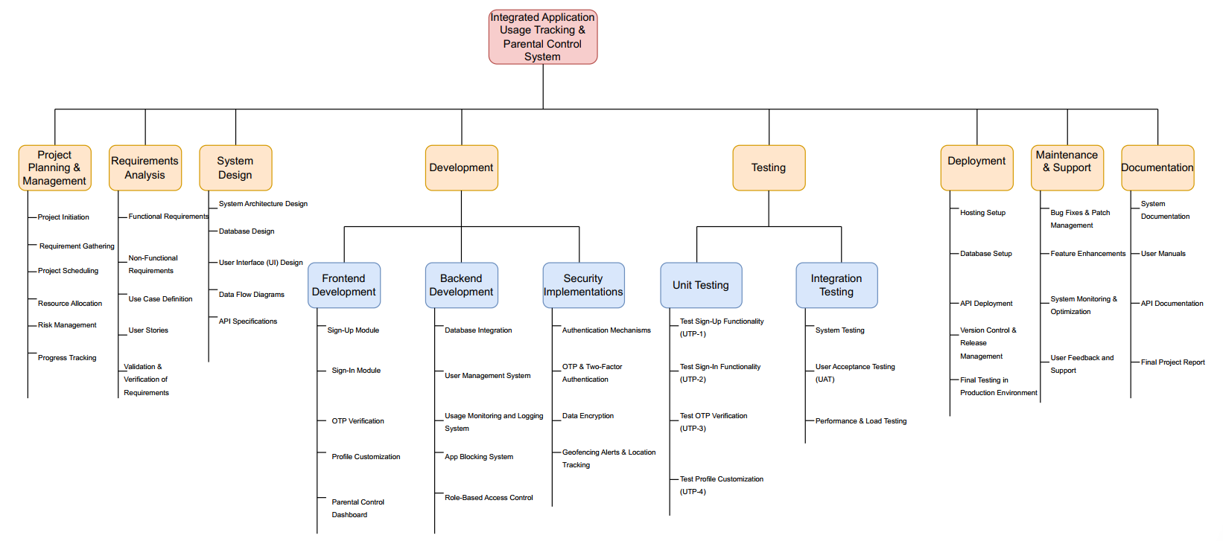

**Timeline Chart-1**

**Organic Model:**

PM=2.4*(5000/1000)^1.05=13

DM=2.5*(13)^.38=6.63(6*4=24 weeks)

ST=13/6.63=1.96 = 2 person

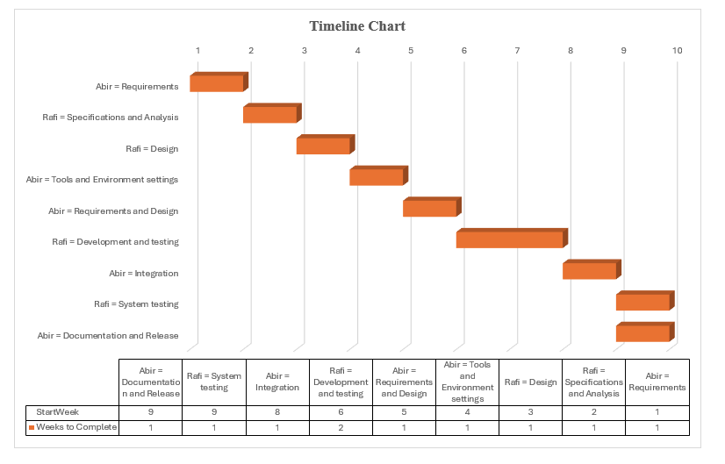

**Timeline Chart-2**

# Risk Management:

|  |  |  |  |  |
| --- | --- | --- | --- | --- |
| **Risk** | **Category** | **Probability** | **Impact** | **Mitigation Strategy** |
| Size estimate may be significantly low | PS (Project Size) | 60% | 2 | Perform a detailed analysis of requirements. |
| Large number of users than planned | PS (Project Size) | 35% | 3 | Break down tasks for better estimation. |
| Less reuse than planned | PS (Project Size) | 70% | 3 | Plan for scalability from the start. |
| Deviation from defined software development process | PR (Process) | 40% | 2 | Use cloud-based services for easy scaling. |
| Delivery might exceed deadline | BU (Business) | 45% | 2 | Prioritize reusable code design. |
| Project budget might exceed deadline | BU (Business) | 40% | 2 | Implement modular coding practices. |
| Unavailability of necessary tools | DE (Development) | 70% | 1 | Conduct regular process audits. |
| Personnel shortfalls | DE (Development) | 20% | 1 | Ensure team adherence to development methodologies. |
| Developing the wrong software functions | TE (Technical) | 5% | 4 | Establish clear milestones. |
| Developing the wrong user interface | TE (Technical) | 5% | 1 | Regular progress tracking and reporting. |
| Late changes to requirements | BU (Business) | 30% | 1 | Maintain a strict budget tracking process. |
| Development technically too difficult | ST (Technical Skills) | 10% | 3 | Plan for contingency funds. |
| **Risk** | **Category** | **Probability** | **Impact** | **Mitigation Strategy** |
| Security vulnerabilities | TE (Technical) | 30% | 2 | Identify alternative tools in advance. |
| Inexperienced staff | ST (Technical Skills) | 35% | 2 | Maintain a list of backup resources. |
| Important staff unavailable on-site | ST (Technical Skills) | 10% | 2 | Cross-train staff. |
| Interface design might not be user-friendly | BU (Business) | 30% | 2 | Keep a pool of backup resources. |
| Ethical dilemma | CU (Cultural) | 40% | 4 | Maintain clear communication with stakeholders. |
| High maintenance costs due to poor design | DE (Development) | 50% | 2 | Conduct early validation of requirements. |
| Data privacy concerns | TE (Technical) | 45% | 2 | Engage in frequent UI/UX testing. |
| Miscommunication between team members | PR (Process) | 35% | 3 | Get continuous feedback from users. |
| Dependency on third-party services | ST (Technical Skills) | 30% | 3 | Implement change management practices. |
| Low user adoption due to lack of marketing | BU (Business) | 40% | 3 | Allow buffer in the timeline for changes. |
| Regulatory non-compliance | CU (Cultural) | 20% | 4 | Ensure skill alignment with project requirements. |

Impact values:

1–catastrophic

2–critical

3–marginal

4–negligible